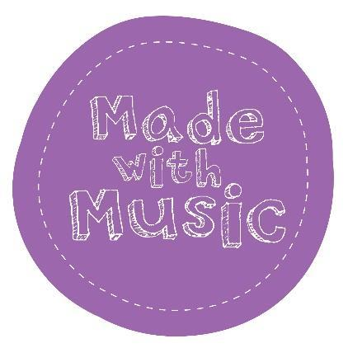

Privacy Policy

Made with Music is a Charitable Incorporated Organisation providing accessible and educational live music experiences for families and young people in and around Leeds. We are committed to protecting your privacy. We will use your personal information in accordance with the Data Protection Act 1998, and other laws that set out how we can use your personal information. We do not require you to give us any personal information to use our website, feel free to have a look around at all the work we do and get in touch if you have any questions or comments about it.

What information do we collect?

To fulfill our booking system, we collect information you provide including name, title, email address, address or phone number, depending on the nature of your request. We may also ask for information about other Made with Music activities you may be interested in.

The photos we use on our website are done so with permission of the subjects. If at any time, you change your mind, please email us at hello@madewithmusic.co.uk and we will stop using that image within 5 working days.

Why do we collect your data?

- We want you to be the first ones to know about our classes and other opportunities to bring music into your lives! We occasionally need to tell you a class has been cancelled or that we have a special event coming up. Having your email address is the quickest way for us to contact you and give you this information.
- You may receive marketing communications from us if you booked a class or asked for information from us about our goods or services or, if you are not a customer, you gave us your details and agreed to receive marketing communications by ticking a box and in each case you have not since opted out of receiving such communications.
- We do not sell your personal data to third parties.
- Whilst we will never share your details with a third party, if we receive information about an event or opportunity, we feel is relevant to you/your family, we may forward information onto you.
How do we store your data?
Our website is hosted on the Wix.com platform. Wix.com provides us with an online platform that allows us to sell our products and services to you. Your data may be stored through Wix.com’s data storage, databases and the general Wix.com applications. They store your data on secure servers behind a firewall.

We use TicketSource to sell tickets to our events. Your data will be encrypted on their servers, and we do not download it from their website. No financial information is stored. TicketSource has their own Privacy Policy and you can access it on their website.

We keep the termly registers with your name on, but no other personal information is kept in the same document. Children’s names are never kept together with addresses or any other identifiable information and only the name that we use in class is stored.

You can ask us or third parties to stop sending you marketing messages at any time by following the opt-out links on any marketing message sent to you.
If you opt out of receiving marketing communications this opt-out does not apply to personal data provided because of other transactions, such as purchases, warranty registrations etc.
Cookies

Cookies are small text files that can be used by websites to make a user's experience more efficient.
The law states that we can store cookies on your device if they are strictly necessary for the operation of this site. For all other types of cookies, we need your permission.
We may also automatically receive general information that is contained in our server log files such as your IP address and cookie information. Cookies may be set and used to improve your user experience, such as retaining your personal settings.
Your Legal Rights

Under data protection laws you have rights in relation to your personal data that include the right to request access, correction, erasure, restriction, transfer, to object to processing, to portability of data and (where the lawful ground of processing is consent) to withdraw consent.

You can see more about these rights at:

https://ico.org.uk/for-organisations/guide-to-the-general-data-protection-regulation-gdpr/individual-rights/

If you wish to exercise any of the rights set out above, please email us at hello@madewithmusic.co.uk

You will not have to pay a fee to access your personal data (or to exercise any of the other rights). However, we may charge a reasonable fee if your request is unfounded, repetitive, or excessive, or refuse to comply with your request in these circumstances.

We may need to request specific information from you to help us confirm your identity and ensure your right to access your personal data (such as a passport or driving license). This is a security measure to ensure that personal data is not disclosed to any person who has no right to receive it. We may also contact you to ask you for further information in relation to your request to speed up our response.

We try to respond to all legitimate requests within one month. Occasionally it may take us longer than a month if your request is particularly complex or you have made several requests. In this case, we will notify you.

If you are not happy with any aspect of how we collect and use your data, you have the right to complain to the Information Commissioner’s Office (ICO), the UK supervisory authority for data protection issues (www.ico.org.uk). We should be grateful if you would contact us first if you do have a complaint so that we can try to resolve it for you.

Privacy Policy Updates

We may modify this privacy policy at any time, so please review it frequently. Changes and clarifications will take effect immediately upon their posting on the website. If we make material changes to this policy, we will notify you here that it has been updated, so that you are aware of what information we collect, how we use it, and under what circumstances, if any, we use and/or disclose it.

It is very important that the information we hold about you is accurate and up to date. Please let us know if at any time your personal information changes by emailing us at hello@madewithmusic.co.uk

We are committed to reviewing our policies annually.

This policy was last reviewed in March 2024.

Signed: Kat Porter (Administrator)

