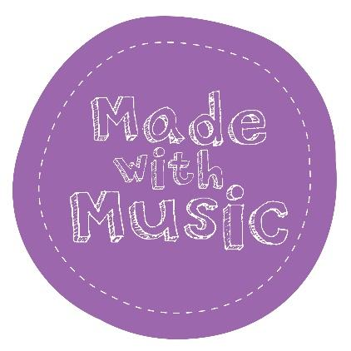
Children and Vulnerable Adults Policy

Made with Music is a not-for-profit charity delivering music workshops in and around Leeds. We are committed to making sure the children and vulnerable adults we work with are kept safe whilst engaging in our work.

This policy applies to all staff, including senior managers and the board of trustees, paid staff, volunteers, students and anyone working on behalf of Made with Music.

The purpose of this policy is to protect children, young people and vulnerable adults who take part in any aspect of Made with Music’s programme of work and to provide staff and volunteers with the overarching principles that guide our approach to safeguarding and child protection.

Legal framework

This framework has been drawn up on the basis of law and guidance that complies with all relevant legislation to protect children from harm, namely (but not solely) Children Act 1989, 2004 / Data Protection Act 1998 / Safeguarding Vulnerable Groups Act 2006 / Children and Families Act 2014 / SEND code of practice: 0-25 years, HM Government 2014.

We recognise that:

- The welfare of the child is paramount, as enshrined in the Children Act 1989.
- All children, regardless of age, disability, gender, racial heritage, religious belief, sexual orientation or identity, have a right to equal protection from all types of harm or abuse.
- Some children are additionally vulnerable due to previous experiences, their level of dependency, communication needs and other issues.
- Working in partnerships with children, young people, their parents, carers and other agencies is essential in promoting the welfare of these young people.

We will seek to keep children and young people safe by:

- Valuing them, listening to, and respecting them.
- Adopting child protection and safeguarding practices through procedures and a code of conduct for staff and volunteers.
- Developing and implementing an effective e-safety policy and related procedures.
- Providing effective management of all staff and volunteers through supervision, support, and training.
- Recruiting staff and volunteers safely. It is our policy that the lead musician will have an up-to-date DBS check and any volunteers who don’t have this will always be supervised and never left to work with children alone. Regular volunteers will have an up-to-date DBS check.
- Recording and storing information professionally and securely.
- Using safeguarding procedures to share concerns and relevant information with agencies who need to know and involve children, young people, parents, families, and carers appropriately.
- Using procedures to manage any allegations against staff and volunteers appropriately.

- Ensuring that we provide a safe physical environment for our children, young people, staff, and volunteers by applying health and safety measures in accordance with the law and regulatory guidance. We cannot guarantee there will always be a first aider on site

Contact Details

Designated Safeguarding Officer: Tamsyn Durrant (Trustee) | 07974371403 | Tamsyn271@gmail.com

Deputy Safeguarding Lead: Hannah Dilworth (Director) | 07791809121 |hello@madewithmusic.co.uk

NSPCC helpline 0808 8005000

We are committed to reviewing our policies annually.

This policy was last reviewed in March 2024.

Signed: Kat Porter (Administrator)

